**Bell Ringer:** Everybody’s Shuffling

*AP Biology*

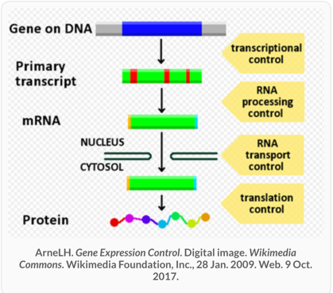

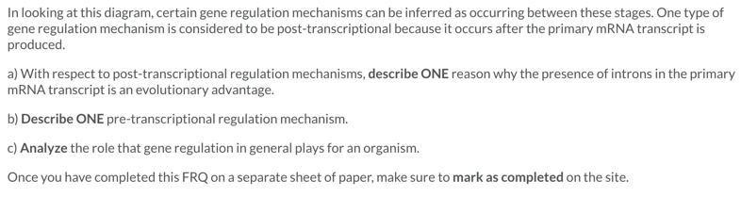

**Bell Ringer**: Everybody’s Shuffling

*AP Biology*



